# IIT PATNA

# Security System

# **A project by** -:

# ASHUTOSH KUMAR (1501CS14) & VAIBHAV SHISODIYA (1501CS48)

# Contents

1. Objective …………………………………………………..
2. Advantage Over Older System …………………..
3. Methodology And Approach Used …………….
4. Working …………………………………………………….
5. Conclusion …………………………………………………..
6. References ……………………………………………….

Objective

Our main task is to provide online server for storing entry gates records by automating the whole process using finger print sensors and raspberry pie. We are taking the finger print of the person coming in or going out from campus and in-time, out-time is being stored in database containing certain information about the person.

Therefore no one have to manually enter their all details each time they go out or come in the campus. They just have to put their finger on the sensor and all done.

Advantage Over Older System

This will ensure that no one alter the records, in case of any security issues. Also we can ensure the safety of our campus as in case of thefts it would so easy to go through persons who have gone out or come in campus during that day in such time slots.

There would also be no fear of losing record books as we have everything on our database. This will also reduce all that labor of entering all the details each time someone has to go out of the campus

Since the identity of the person is detected biometrically there would be no case of fake inputs.

Methodology And Approach Used

We created a MySQL based server. User’s personal information and check in/out data are stored in different tables. There are two categories for users to access the stored data (Admin and Student). Students will have limited access to the information available.

A desktop app is created based on JavaFX so that users can access the data.

A different java application has been created based on JavaSwing *(Since javaFX is not supported in ARM based machines).* The application will provide user interface for fingerprint sensing and registration process. Application is connected to the database, so it will update data to the server. Since there was no direct method to communicate to the fingerprint sensor, Arduino is used to run fingerprint libraries and send back the confirmation code to raspberry pi.

Working

User must register for the first time. Once registration process is done, user can now use fingerprint sensor to check-in or check-out.

# Steps For Registration:

Fill the details required in the blocks provided and click on “SCAN FINGERPRINT AND REGISTER” to scan the finger and register. If it is successful a message saying “ENTRY DONE….” Will be displayed or try again.

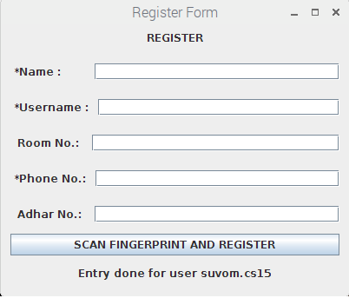

Now the user just has to place his finger on sensor for updating his detail and it’s done.

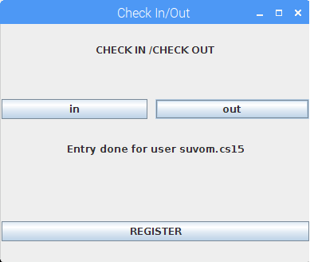

Same has to be done for checking out.

Later on user can anytime view his last check in/out status or of his friends by logging in and entering his roll number.

Admin has full access of details of all the students and the people from outside of the campus.

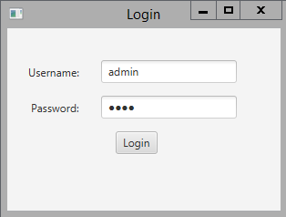

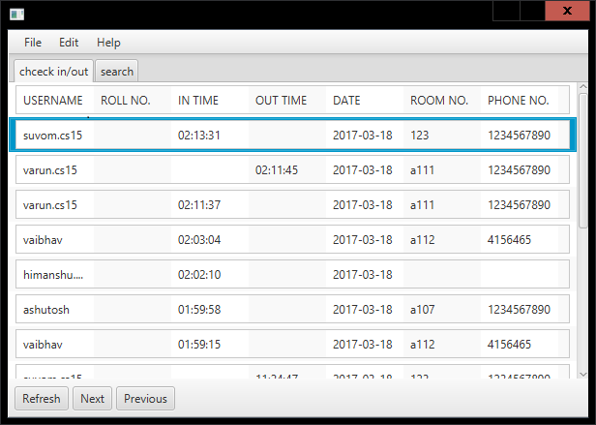

Admin can also check the details of single student.

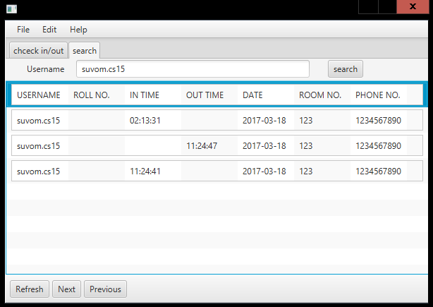

Students too have access to view their last entry details and they can also check for their friends last entry details too.

The login password for students will be provided by admin itself.

After a student is enrolled by admin he will authorised to view certain details.

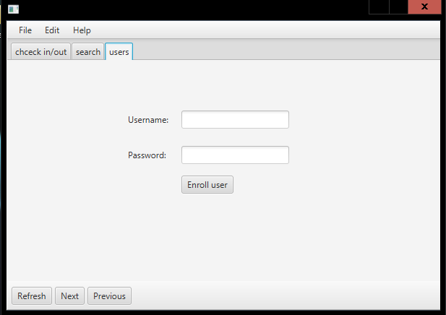

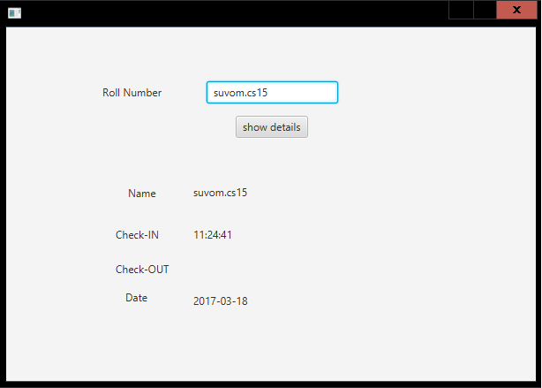

This shows the details of some user which student has access to. Blank blocks means he/she has not checked –in/out of the campus.

Conclusion

Our project is fully functional and ready to reduce the problems caused to the students and staffs as they have to suffer due to manual entry. There was also case of things missing from campus and no one was able to find the guilty which now is not a threat anymore. Everyone details is now available on the basis of their daily movement in/out of the campus. This also reduces the tough task of maintaining the registers and reduces some labor work which was required earlier near gates. This can also be implemented on buses going out of the campus and the details of students and staffs going out can be stored which was earlier not possible which adds to the extra details and safety of people going out. This can be implemented in classroom and library for attendance and to take records of the persons who takes books on daily basis. This can be used to take attendance of the guards in campus which can’t be messed with or changed as that will stored in a database which only admin can access.

References

1. Stack Overflow
2. https://docs.oracle.com/javafx/
3. [*https://dev.mysql.com/doc/*](https://dev.mysql.com/doc/)
4. [*https://github.com/adafruit/Adafruit-Fingerprint-Sensor-Library*](https://github.com/adafruit/Adafruit-Fingerprint-Sensor-Library)
5. [*https://docs.oracle.com/cd/E17802_01/products/products/javacomm/reference/api/javax/comm/SerialPort.html*](https://docs.oracle.com/cd/E17802_01/products/products/javacomm/reference/api/javax/comm/SerialPort.html)